iStockphoto.com/chromatika

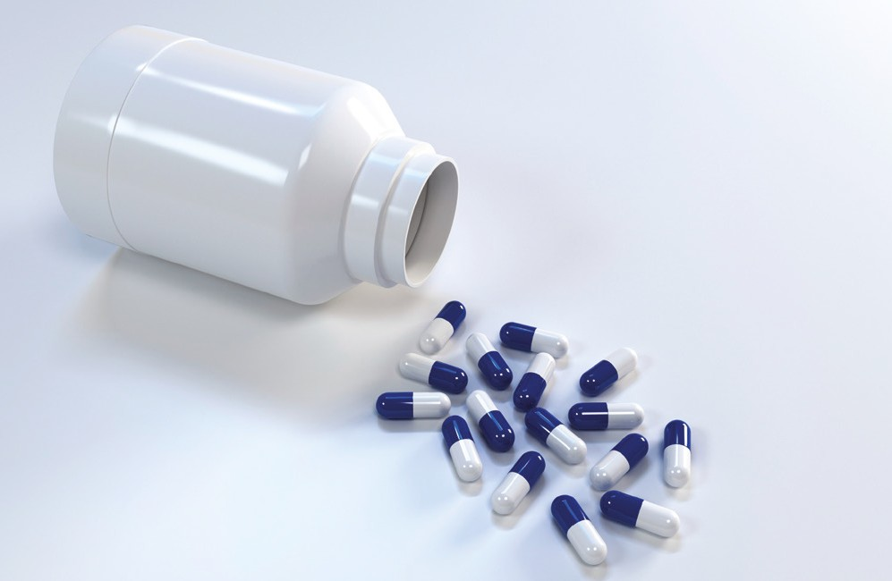

**Drugs in sport**

**Drugs in sport** caffeine diuretics Anabolic steroids

Human growth hormone (HgH) beta blockers

blood doping erythropoietin (ePo)

legal methods to improve performance drug testing

Participation for all

# **Drugs in sport**

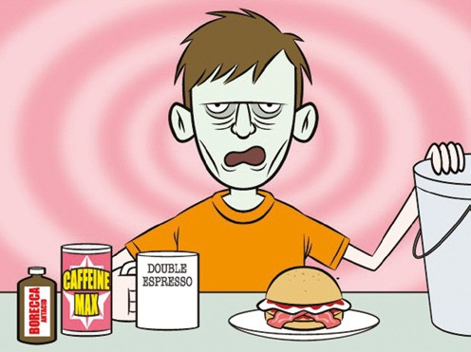Illegal drug use captures media attention, but the most commonly used drugs are legal. Caffeine is a legal drug and as such is not listed on the *World Anti Doping Code (2008).*

## **Caffeine**

Caffeine is one of our most socially accepted drugs. It is a stimulant found in coffee, tea, cola drinks, chocolate and stimulant tablets such as *No-Doz*. As a stimulant, caffeine has rapid short-term effects such as:

* energy release in your muscles
* shaking or trembling hands
* increased body temperature
* increased urine production.

List some other effects:

Large doses of caffeine can cause headaches, shakiness, nervousness, delirium and even death. Consuming six or more cups of coffee a day—or three cans of a cola soft drink, two chocolate bars and one coffee—may give you:

* chronic insomnia
* persistent anxiety.

List some other effects:

A regular intake of about five cups of coffee daily causes physical dependence on caffeine. People who are physically dependent show classic withdrawal symptoms—severe headache, irritability and tiredness.

### *Dangers of caffeine*

1. How could caffeine be misused?
2. Is caffeine potentially dangerous for some people? Explain how.
3. What ethical issues arise if caffeine is used for improved performance at a school carnival?
4. As a class, debate whether caffeinated drinks should be used in school sports. Plan your arguments in the space provided.

## **Diuretics**

Diuretics are used by athletes to stimulate urine production. This aids athletes who participate in sports where weight is an issue, for example weight-lifting and horseracing. Diuretics are also used by some athletes to dilute their urine to mask the use of particular drugs such as anabolic steroids. Dehydration is a common side effect of diuretic use and abuse may also lead to kidney problems.

### *Diuretics as medication*

1 Diuretics are widely available within our community. What non-sporting reasons may someone have for taking this as a form of medication?

## **Anabolic steroids**

Anabolic steroids have received enormous amounts of publicity in recent years because athletes in many sports have been using them to win by cheating. However, a much more serious problem has arisen: there is now a trend towards adolescent abuse of steroids as a result

Shutterstock.com/Yeko Photo Studio

of media pressure, inappropriate role models and availability. Australia follows America in many social trends, and steroid abuse by teenagers appears to be one of these trends. Recent studies have also shown that it is not just boys taking steroids. Girls are starting to experiment in their quest to achieve the perfect body.

Anabolic steroids can cause a host of harmful side effects, some of which may not become apparent until years later. Initial side effects can include

jaundice, acne, trembling, fluid retention and high blood pressure. More insidious, long-term effects include an increased risk of stroke and heart attack, infertility, and, in young people, stunted growth. In men, steroid use can lead to reduced testicle size, breast growth, and premature baldness. Steroids can also cause masculine traits to develop in women, such as a deeper voice, larger clitoris, facial hair and smaller breasts, as well as causing periods to become irregular or stop altogether.

### *Effects of steroids*

1. Conduct research online on the different effects and side-effects of steroids, then label them on the diagram provided.

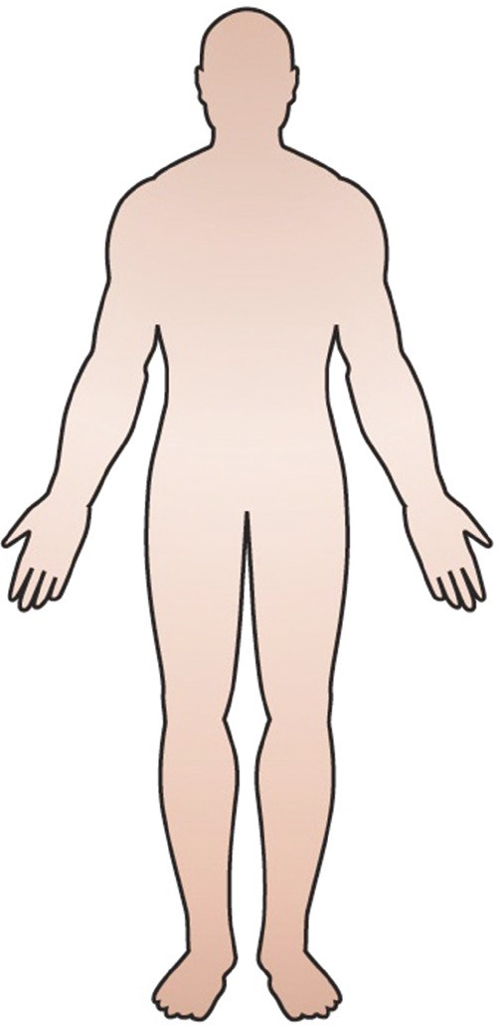

1. Are male or female adolescents more likely to use steroids? Where does the pressure to use steroids come from?

## **Human growth hormone (HGH)**

Human growth hormone (HGH) is used by athletes to promote physical growth. It has the ability to increase red blood cells, increases heart function and increases available energy. It is often used by athletes requiring strength and power for their sport.

Athletes who abuse HGH may develop diabetes and are at risk of heart failure.

## **Beta blockers**

Beta blockers are taken to reduce stress and anxiety therefore they are advantageous in sports such as shooting and archery where fine motor control is important.

## **Blood doping**

Blood doping is where blood is taken from an athlete in the weeks leading up to a competition to be injected in to them just prior to their race or event. The advantages of this are that the increased blood volume improves oxygen intake.

## **Erythropoietin (EPO)**

Erythropoietin (EPO) is an artificial hormone designed to stimulate the production of red blood cells thus allowing the blood to carry more oxygen. This drug is advantageous for endurance athletes such as cyclists.

When too much EPO is absorbed into the body the increased number of red blood cells can cause clotting, heart attacks, strokes and even death.

### *Illegal usage*

* 1. What type of sports would benefit from blood doping?
  2. Drugs that are sold legally in shops must be labelled carefully and there is strict control over the ingredients. What is the situation for drugs that are sold illegally? If you bought a bad batch of illegal drugs, how could you tell, and what could you do about it?
  3. Many people would not pick a lolly up off the ground and eat it, and would think twice about taking one from a stranger; however people will still buy illegal drugs from someone they do not know. Write what you would say to a friend who is considering testing an illegal substance to improve their performance.

## **Legal methods to improve performance**

Legal methods that athletes use to improve performance include consuming sports drinks and using creatine, which is utilised by the muscles to provide instant energy.

Training at higher altitudes is also believed to be an advantage to endurance athletes as it trains the body to perform on lower amounts of oxygen. As a result, when the athlete competes in countries with a lower altitude their body is more efficient in using oxygen.

### *Legal versus illegal enhancement drugs*

1. In pairs, use the internet to research examples of other legal ergogenic aids that can be used by athletes to increase performance. Discuss your findings with your class.
2. Complete the table, listing the type of ergogenic aid represented.

|  |  |  |
| --- | --- | --- |
| **Ergogenic aid** | **Pharmacological, physiological, nutritional, mechanical, psychological** | **Use in sport (legal/illegal)** |
| Creatine |  |  |
| Blood doping |  |  |
| Carb-loading |  |  |
| Anabolic steroids |  |  |
| Altitude training |  |  |
| EPO |  |  |
| Hypnosis |  |  |
| Nasal strips |  |  |

1. What do you think is meant by this statement:

*‘Just because some drugs are legal to take it does not mean taking them to improve performance is ethical.’*

1. With so many credible and legal alternatives to drug taking why do you think athletes still choose unethical options to increase performance? Discuss your results as a class.

## **Drug testing**

The Australian Sports Anti-Doping Authority (ASADA) conducts regular analysis of Australian athletes. ASADA implements the World Anti-Doping Code. See <*flexibooks.com.au/w/hv*>.

While codes of sport conduct their own tests, sporting bodies make athletes available to testing on a program determined by ASADA.

ASADA testing follows protocols of analysis:

#### *Urine*

* The laboratory will analyse part ‘A’ of an athlete’s urine sample for the presence of prohibited substances or doping methods.
* If part ‘A’ of a urine sample returns an adverse analytical finding the athlete has the right to have part ‘B’ of his or her urine sample analysed to confirm the analytical result.

#### *Blood*

* The laboratory will analyse an athlete’s blood sample for the purpose of detecting the use of prohibited substances or methods.
* If the sample returns an adverse analytical finding the athlete maintains the right to have confirmatory procedures performed in relation to this analysis.
* There is no available testing method for EPO however testing is performed to measure the number of red blood cells present in blood. This however may only indicate possible EPO abuse and therefore a more reliable test is needed.

Blood testing is often used to test for very recent drug use, i.e. within a couple hours of use. Urine testing detects drug use for a longer period of time. Urine testing is one of the most common methods of testing because it is easier to administer and provides more accurate results.

Masking agents

A masking agent is any substance that is taken or action that is performed to decrease the chance of drug cheating being identified. More efficient technology and strict testing procedures means that it is getting harder and harder for athletes to use these.

### *Random sampling*

There are now protocols for drug testing at major events and competitions, however, drug cheats can be caught at any time. Random sampling involves testing various athletes at different times of the season to ensure that they are not taking drugs prior to an event and stopping within a certain time frame to minimise chances of the drugs being detected.

The use of illegal performance-enhancing drugs contributes to participants making unfair gains in performance and personal bests. This is due to the drugs’ ability to help the athlete recover faster between exhausting training sessions (anabolic steroids, EPO) or to boost the body’s ability to handle performance (beta blockers).

1. Try the doping quiz at <*flexibooks.com.au/w/hw*>
2. Compare the number of athletes who tested positive for drug use at the Sydney, Athens and Beijing Olympics. Write a short report that explains whether you think drug use is declining, growing or staying the same.
3. In small groups, debate the following statements.

a Performance-enhancing drugs should be allowed for all athletes—then the competition would be fair. b Drug testing authorities should have access to an athlete anytime and anywhere.

1. Use the internet to research what the International Olympic Committee (IOC) drug testing protocols are.
2. Drugs in sport not only affect the players but they can have a detrimental effect on the code of sport being played.
   1. As a class, discuss which sports are often in the media due to players taking drugs. What effect does this have on the public’s opinion of the sport and what flow on effect could it have?
   2. What penalties should be imposed on drug users?

## **Participation for all**

Many people invest a lot of time and money investigating ways to achieve an unfair advantage over their opponents in their quest to become the best. On a community level, and from a health perspective, we need to be moving away from this and instead researching ways for all people to have equal access to sport and physical activity.

Individuals participate in sport for a variety of reasons. It is important to consider that different groups have different interests and needs regarding participation in physical activity.

The history of an activity or sport impacts on the way it is played or participated in during modern times. Factors such as gender, class and accessibility have influenced the sports traditionally played in Australia and the groups who participate.

### *Sport and gender*

1. List three sports that are traditionally seen as men’s sports.
2. Why do you think these sports are so closely associated with men?
3. List three sports that are traditionally seen as women’s sports.
4. Why do you think these sports are so closely associated with women?
5. What do you think can be done (or has been done) to make both men and women feel comfortable playing these sports?
6. List some factors that might mean a sport is not accessible for all and explain the reasons behind your choices.

### *Drugs in sport word search*

Find the eleven words hidden in this word search relating to drugs in sport. The words can run forward, backward, diagonally and vertically.

|  |  |  |
| --- | --- | --- |
| **Drugs** | **Steroids** | **Hormones** |
| **Sport** | **Performance** | **Energy** |
| **Caffeine** | **Legal** | **Muscles** |
| **Diuretics** | **Illegal** |  |

|  |  |  |  |  |  |  |  |  |  |  |  |  |  |  |  |  |  |  |
| --- | --- | --- | --- | --- | --- | --- | --- | --- | --- | --- | --- | --- | --- | --- | --- | --- | --- | --- |
| E | E | I | L | L | E | G | A | L | B | S | I | O | L | L | A | G | E | L |
| N | D | R | U | G | S | K | I | U | S | P | E | W | A | R | D | S | A | T |
| I | M | S | T | U | P | O | Q | U | A | O | C | N | M | G | J | K | S | I |
| E | O | N | B | V | G | K | L | Y | U | R | E | N | I | T | U | O | R | O |
| F | T | D | C | V | G | T | D | T | S | T | R | A | T | E | G | I | E | S |
| F | M | A | I | V | T | H | J | K | L | T | Y | U | E | O | O | A | X | V |
| A | U | A | R | U | F | T | Y | S | B | G | N | H | M | H | M | L | S | Q |
| C | S | B | V | C | R | N | C | E | D | T | R | A | T | I | O | N | E | P |
| O | C | M | D | T | C | E | O | I | U | I | E | S | T | R | T | H | N | S |
| F | L | T | H | I | U | N | T | E | W | E | O | S | L | J | O | T | O | S |
| R | E | H | E | K | U | P | Q | I | C | L | Y | R | D | S | U | C | M | M |
| E | S | S | T | A | N | R | T | J | C | L | Y | Z | E | N | B | C | R | T |
| P | R | E | S | S | U | R | E | P | R | S | S | E | T | T | I | E | O | P |
| L | W | E | F | E | G | A | T | T | W | O | T | K | R | D | S | M | H | N |
| D | I | R | E | C | T | I | O | N | S | A | I | S | G | F | A | C | I | N |
| H | Q | E | N | E | R | G | Y | F | B | Y | G | P | U | A | S | N | Y | A |
| L | A | X | Q | C | Q | R | T | G | R | B | E | D | R | U | K | O | L | P |
| X | F | B | U | I | E | G | R | H | U | K | O | K | O | L | P | V | R | C |
| V | Y | W | M | N | P | E | R | F | O | R | M | A | N | C | E | E | C | T |

# **Weighing it up: Assessment task**

Name: Class: Monitoring date: Due date:

## **Extended response**

One of the biggest issues concerning drugs in sport is the use of anabolic steroids. This concern is not limited to athletes, but to many people in the pursuit of a ‘perfect body’. The pressure on young men to look good has increased, with boys as young as 13 using steroids without adequate knowledge of the associated dangers.

Write an argumentative essay that responds to the following statement:

*‘For both men and women, the risks of using steroids far outweigh the benefits.’*

To gather information for your response, complete the following criteria:

* View the YouTube video on the dangerous health effects of steroids *<flexibooks.com.au/w/kj>*
* Read the article at *<flexibooks.com.au/w/jd>*
* Visit the ASADA (Australian Sport Anti-Doping Authority) website at *<flexibooks.com.au/w/je>* and complete a list of:
  + the eight anti-doping rule violations
  + three athletes who have violated the rules. What was their sport, the substance and the sanction they received?

Back up your response with statistics and facts concerning the effects of steroid use.